Hypothesis Testing

Objective:
To test assumptions about customer behavior, sales performance, or satisfaction using statistical methods. This helps validate patterns found during EDA and query analysis.

Hypothesis Steps:
- Loading GSC Files:
# Sample Code:
# libraries
import pandas as pd
import matplotlib.pyplot as plt
import seaborn as sns
from scipy.stats import ttest_ind, chi2_contingency
from scipy.stats import shapiro, mannwhitneyu

# Loading GCS files
customers = pd.read_csv("gs://ppnj_data/files/dim_customer.csv")
travel_package = pd.read_csv("gs://ppnj_data/files/dim_travel_package.csv")
sales = pd.read_csv("gs://ppnj_data/files/fact_sales.csv")
travel_guide = pd.read_csv("gs://ppnj_data/files/dim_travel_guide.csv")
feedback = pd.read_csv("gs://ppnj_data/files/dim_feedback.csv")
refund = pd.read_csv("gs://ppnj_data/files/dim_refund.csv")

customers.head()

# Sample data:
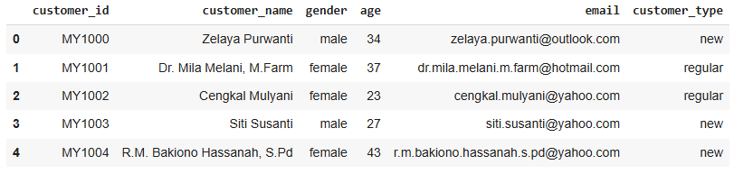

- Hypothesis: Feedback Score vs Refund Request
Hypothesis Objective:
- To determine if theres significant diference in satisfaction score between customer who requested for refund vs those who didn't
- Ho: No difference in average feedback scores between refund vs non-refund customers
- H1: Theres significant difference feedback scores
# Hypothesis Testing:
# data preparation

#refund.head()
refund['requested_refund'] = True # to annotate column where fund has beedn proceed

feedback_refund = feedback.merge(refund[['booking_id','requested_refund']], on='booking_id', how='left')
feedback_refund['requested_refund'] = feedback_refund['requested_refund'].fillna(False)
#feedback_refund.head()

# get satisfaction scores
refund_scores = feedback_refund[feedback_refund['requested_refund']]['satisfaction_score']
no_refund_scores = feedback_refund[~feedback_refund['requested_refund']]['satisfaction_score']

# t-test
t_stat, p_val = ttest_ind(refund_scores, no_refund_scores, equal_var=False)
print(f"T-statistic: {t_stat:.3f}, P-value: {p_val:.4f}")
Output: T-statistic: 0.986, P-value: 0.3386

# Visualize Distribution:
# Visualize Distributions

feedback_refund['refund_status'] = feedback_refund['requested_refund'].map({True:'Refunded', False:'Not Refunded'})

# boxplot
plt.figure(figsize=(6, 4))
sns.boxplot(data=feedback_refund , x='refund_status', y='satisfaction_score', palette='Set2')
plt.title('Satisfaction Score Distribution by Refund Status')
plt.xlabel('Refund Status')
plt.ylabel('Satisfaction Score')
plt.grid(True)
plt.show()

# kde plot
plt.figure(figsize=(6,4))
sns.kdeplot(refund_scores, label='Refunded', shade=True)
sns.kdeplot(no_refund_scores, label='Not Refunded', shade=True)
plt.title('Satisfaction Score Distribution by Refund Request')
plt.xlabel('Satisfaction Score')
plt.legend()
plt.grid(True)
plt.show()

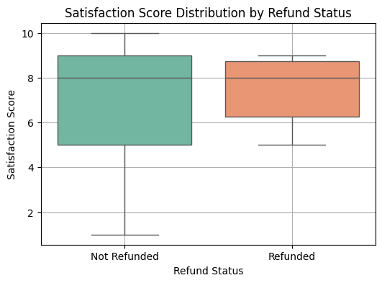

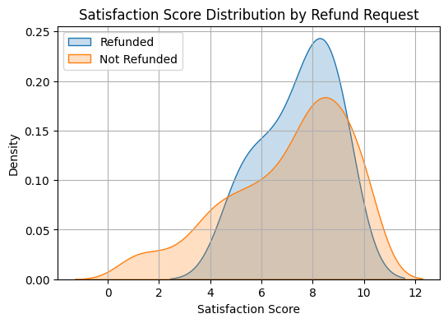

# Normality Checks:
# Normlaity Checks use Shapiro and Mannwhitneyu

shapiro_refund = shapiro(refund_scores)
shapiro_no_refund = shapiro(no_refund_scores)
print("Shapiro-Wilk Test (Refunded):", shapiro_refund)
print("Shapiro-Wilk Test (Not Refunded):", shapiro_no_refund)

stat, p = mannwhitneyu(refund_scores, no_refund_scores, alternative='two-sided')
print(f'Mann-Whitney U statistic = {stat:.4f}, p-value = {p:.4g}')
Output:
Shapiro-Wilk Test (Refunded): ShapiroResult(statistic=np.float64(0.8763830335203862), pvalue=np.float64(0.05162931928281731))
Shapiro-Wilk Test (Not Refunded): ShapiroResult(statistic=np.float64(0.9130226953052021), pvalue=np.float64(2.588473381120319e-12))
Mann-Whitney U statistic = 2215.0000, p-value = 0.8286

# Results Inferences:
T_test:
- p = 0.3386 > 0.05, fail to reject Ho.
- There is no statistically difference in satisfaction scores between customers who requested refund and those who did not
Bases on this test, refund requests do not appear to have a significant effect on satisfaction scores.
Sahpiro Wilk-Test:
- checking for data normality
- Refunded
- Shapiro-Wilk Test (Refunded): ShapiroResult(statistic=np.float64(0.8763830335203862), pvalue=np.float64(0.05162931928281731))
- p > 0.05, we fail to reject the null hypothesis — the data is likely normally distributed.
- Non-Refunded
- Shapiro-Wilk Test (Not Refunded): ShapiroResult(statistic=np.float64(0.9130226953052021), pvalue=np.float64(2.588473381120319e-12))
- p < 0.05, we reject the null hypothesis — the data is not normally distributed.
- proceed with Mann-Whitney U test:
- Mann-Whitney U statistic = 2215.0000, p-value = 0.8286
- p >= 0.05: No significant difference

- Discount Promotion vs Satisfaction Score
Hypothesis Objective:
- Does giving a discount improve customer satisfaction? :
Improve the approach steps of steps - visualize - normality checks - hypothesis test.
- Ho: The average satisfaction score is the same whether a discount is applied or not.
- H1: Satisfaction scores differ depending on whether a discount is applied.

# Visualize Distribution:
# Visualize distributions

#violinplot
feedback_sales['discount_status'] = feedback_sales['discounted'].map({True:'Discounted', False:'Not Discounted'})
plt.figure(figsize=(6,4))
sns.violinplot(data=feedback_sales, x='discount_status', y='satisfaction_score')
plt.title('Satisfaction Score by Discount Status')
plt.xlabel('Discount Status')
plt.ylabel('Satisfaction Score')

# kdeplot
plt.figure(figsize=(6,4))
sns.kdeplot(discounted_scores, label='Discounted', shade=True)
sns.kdeplot(non_discounted_scores, label='Not Discounted', shade=True)
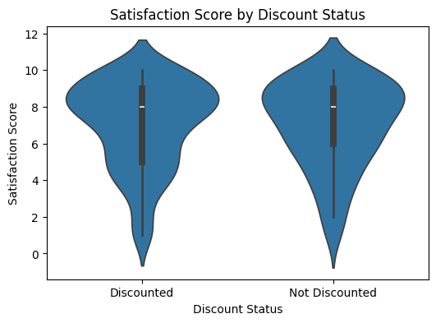
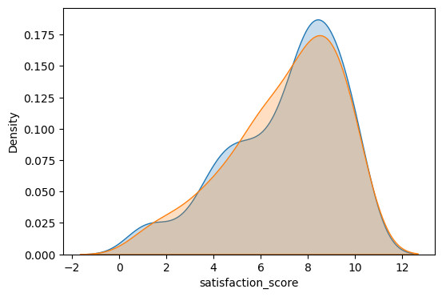

# Normality Checks:
• Based on the visualizations (KDE and violin plots), both distributions appear to be **left-skewed**, particularly for the discounted group.
• This suggests that the data may not be normally distributed.
• However, visual inspection is subjective. To confirm this assumption, we perform the **Shapiro-Wilk test** for normality on both groups.
Shapiro-Wilk tests
print("Shapiro-Wilk (Discounted):", shapiro(discounted_scores))
print("Shapiro-Wilk (Not Discounted):", shapiro(non_discounted_scores))
Output:
Shapiro-Wilk (Discounted): ShapiroResult(statistic=np.float64(0.9083223587253086), pvalue=np.float64(1.3553450336934056e-09))
Shapiro-Wilk (Not Discounted): ShapiroResult(statistic=np.float64(0.9193366359259708), pvalue=np.float64(1.3270511674836503e-06))

# Hypothesis Testing
# data preparation

#print(feedback.columns)
#print(sales.columns)

feedback_sales = feedback.merge(sales[['booking_id', 'discount_promotion']], on='booking_id')
feedback_sales['discounted'] = feedback_sales['discount_promotion'] > 0
#feedback_sales.head()

discounted_scores = feedback_sales[feedback_sales['discounted']]['satisfaction_score']
non_discounted_scores = feedback_sales[~feedback_sales['discounted']]['satisfaction_score']

#print(discounted_scores.head())
#print(non_discounted_scores.head())

# Mann-Whitney U test
u_stat, p_val = mannwhitneyu(discounted_scores, non_discounted_scores, alternative='two-sided')
print(f"Mann-Whitney U statistic = {u_stat:.4f}, p-value = {p_val:.4f}")

alpha = 0.05
if p_val < alpha:
print("Result: Significant difference in satisfaction scores between discounted and non-discounted customers.")
else:
print("Result: No significant difference in satisfaction scores based on discount status.")

Output:
Mann-Whitney U statistic = 12367.5000, p-value = 0.8561
Result: No significant difference in satisfaction scores based on discount status.

#Results Inferences:
Sahpiro Wilk-Test:
- checking for data normality
- Discounted
- Shapiro-Wilk (Discounted): ShapiroResult(statistic=np.float64(0.9083223587253086), pvalue=np.float64(1.3553450336934056e-09))
- p < 0.05, we reject the null hypothesis — the data is likely not normally distributed.
- Non-Refunded
- Shapiro-Wilk (Not Discounted): ShapiroResult(statistic=np.float64(0.9193366359259708), pvalue=np.float64(1.3270511674836503e-06))
- p < 0.05, we reject the null hypothesis — the data is not normally distributed.
Mann-whiteny u test:
- p = 0.8561 > 0.05,fail to reject Ho.
- The average satisfaction score is the same whether a discount is applied or not.
There is no statistically significant difference in satisfaction scores between customers who received a discount and those who didn’t.

Overall Summary
- Both hypotheses fail to reject the null hypothesis.
- Neither refund requests nor discount promotions show a statistically significant effect on customer satisfaction scores.
- Discounts influence conversion positively.
- Satisfaction score is a strong predictor of word-of-mouth (recommendation).
- Refunds often stem from dissatisfaction — a signal for operations to investigate further.
- Recommends further exploration into other drivers of satisfaction, such as travel experience, guide quality, or destination features.

